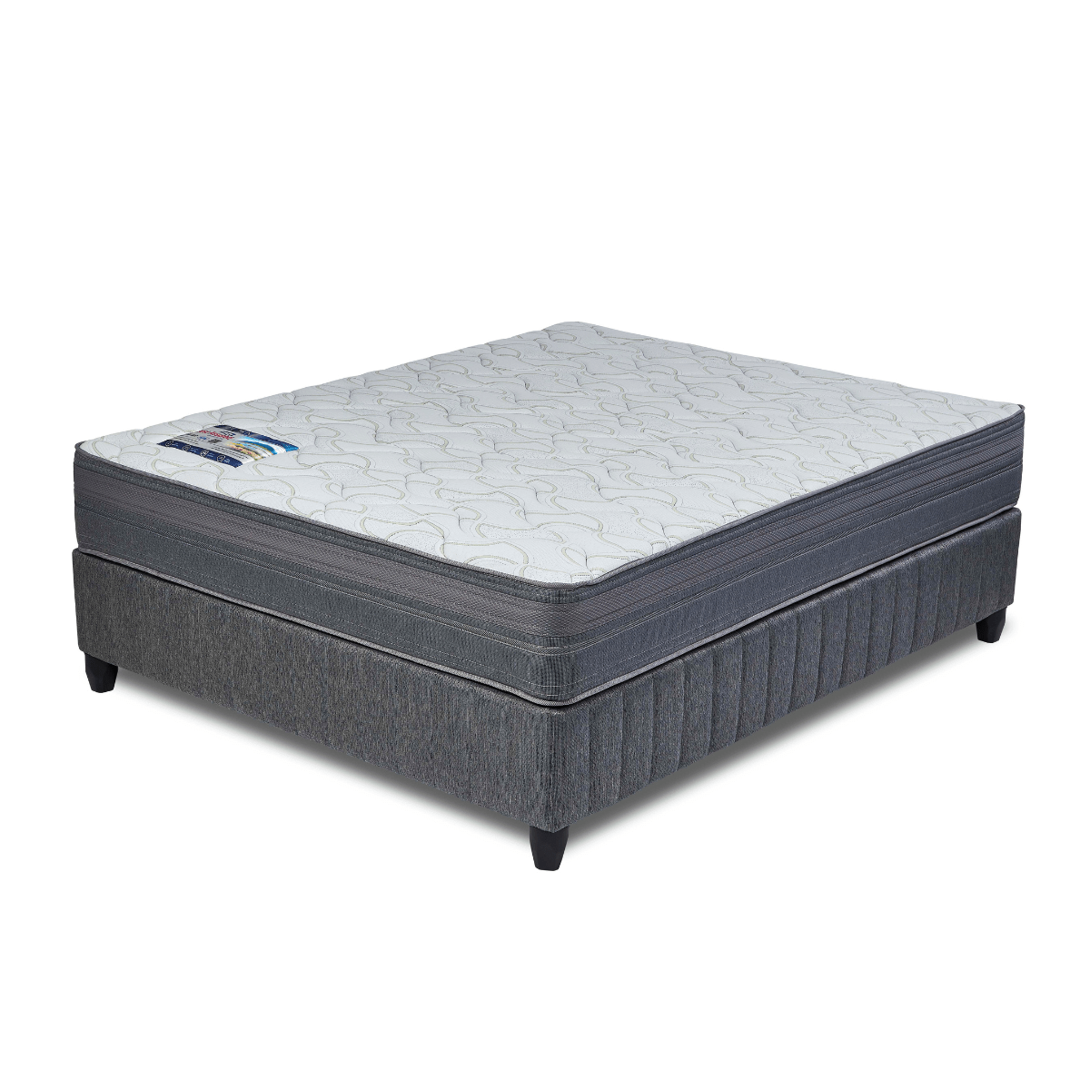
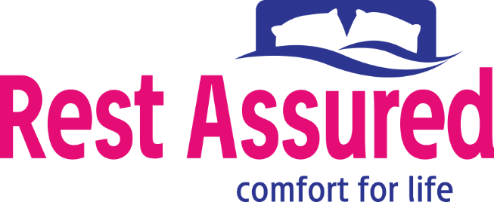

Model : York Base Set
Supplier/Manufacturer : Rest Assured
Range : Heritage Bonnel Coil Collection
Prices – Bed Set :
- Single Bed Set – R5859
- Three Quarter Bed Set – R6509
- Double Bed Set – R7739
- Queen Bed Set – R8149
- King Bed Set – R10819
Prices – Mattress Only :
- Single Mattress Only – R4209
- Three Quarter Mattress Only – R4679
- Double Mattress Only – R5709
- Queen Mattress Only – R6069
- King Mattress Only – R7509
Prices - Extra Length Bed Set :
- Single Extra Length Bed Set – R6329
- Three Quarter Extra Length Bed Set – R7029
- Double Extra Length Bed Set – R8359
- Queen Extra Length Bed Set – R8799
- King Extra Length Bed Set – R11689
Prices - Extra Length Mattress Only :
- Single Extra Length Mattress Only – R4549
- Three Quarter Extra Length Mattress Only – R5059
- Double Extra Length Mattress Only – R6169
- Queen Extra Length Mattress Only – R6559
- King Extra Length Mattress Only – R8109

*Please use this link for guideline for creating the page* - https://www.bedsonline.co.za/product/rest-assured-york-queen/
Rest Assured Link - https://restassured.co.za/our-ranges/heritage/york/

